John Michael Go
Career Entry Level Java Programming
Date: Jan. 22, 2013

DAY 8

Program Name: Array1

Objective: Program that shows length of an array.

Algorithm:

1. Program outputs length of an array.

Flowchart:

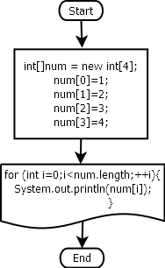

Pseudocode:

public class Array1 {

public static void main(String[] args) {

int[]num = new int[4];
num[0]=1;
num[1]=2;
num[2]=3;
num[3]=4;
System.out.println(num.length);

for (int i=0;i<num.length;++i){
System.out.println(num[i]);
}
}

}

Screenshot:

